**Amar Gajanan Mohite**

Section – IFT562

**Arizona State University**

Instructor**:** Daniel Wells

**Lab 2 – Using AWS Systems Manager**

Date – 14/01/2024

* Task 1's inventory list output.

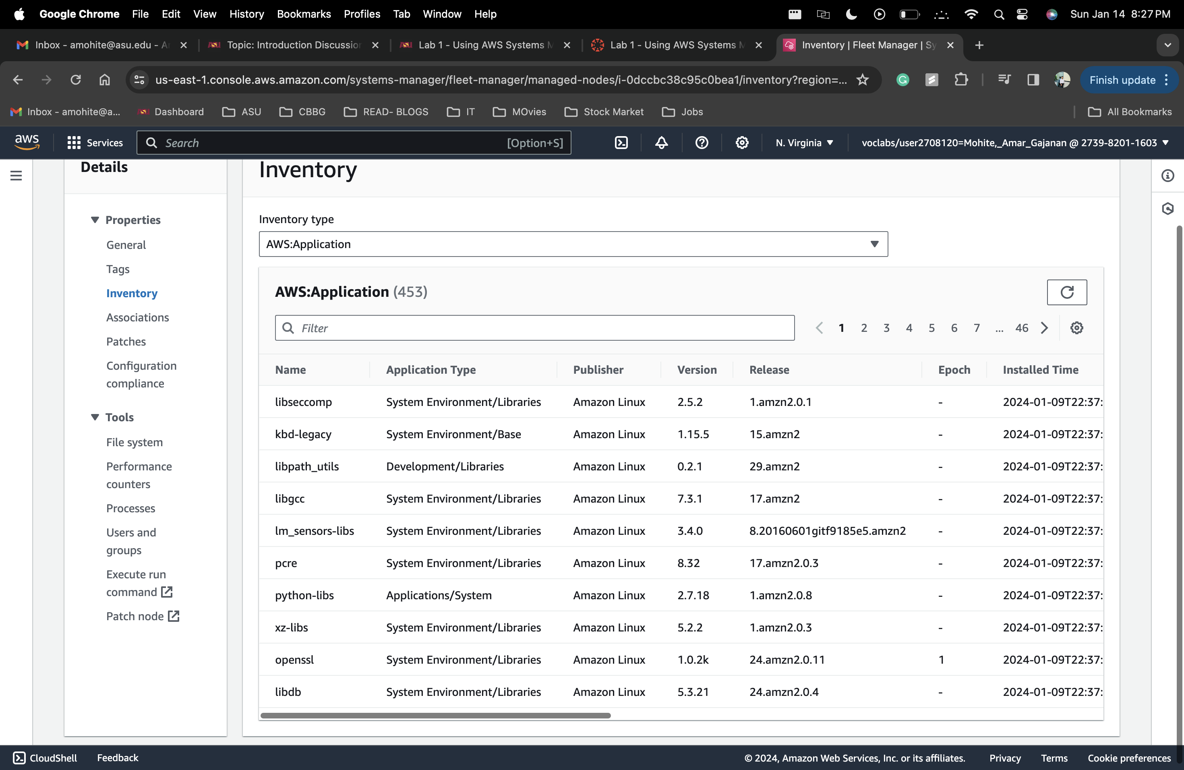

* The web page you browse two at the end of Task 2.  Enter your full name in the address bar of your browser for the screenshot.

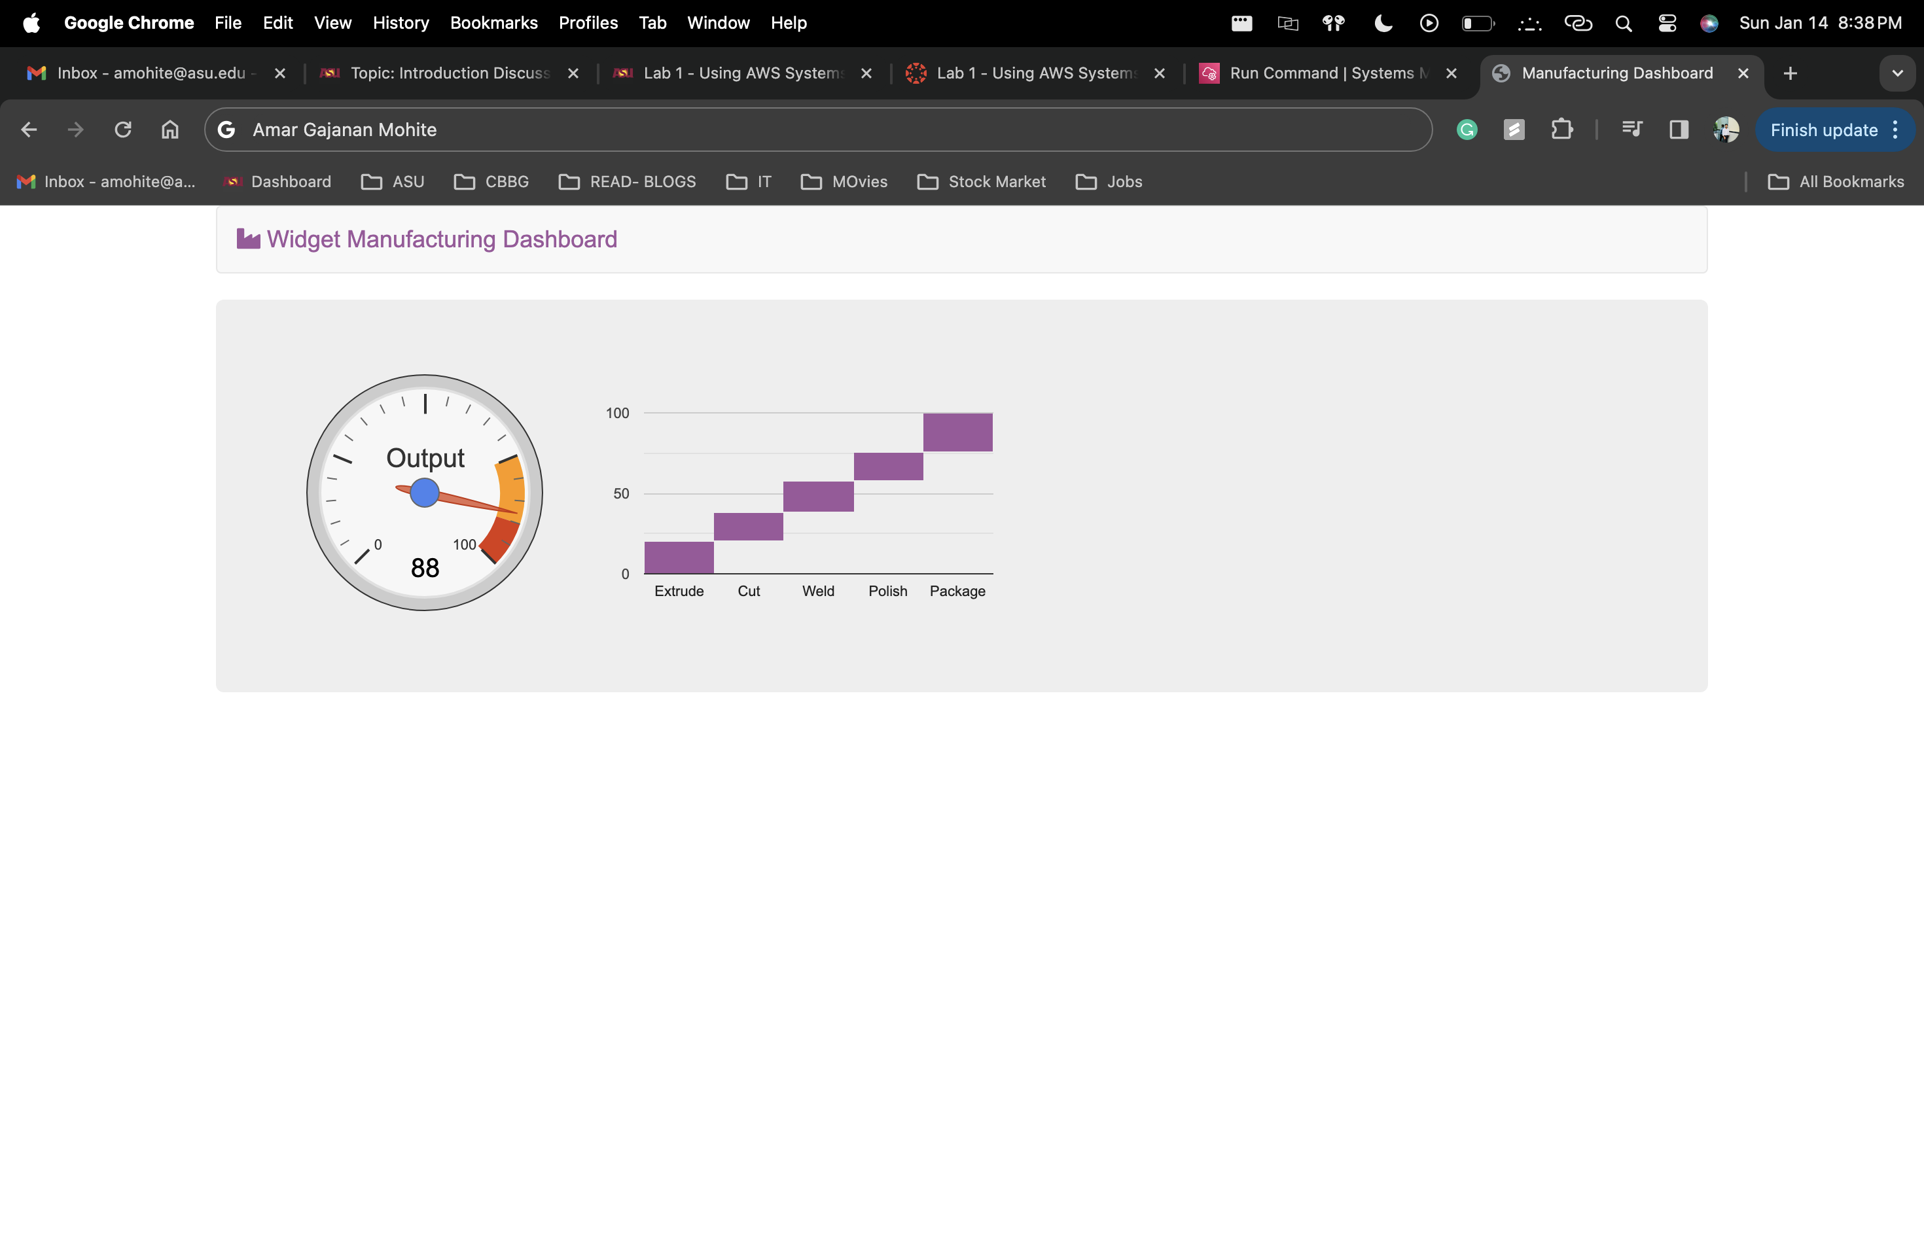

* The list of parameters from Task 3, add your name to the description tab of any parameter.

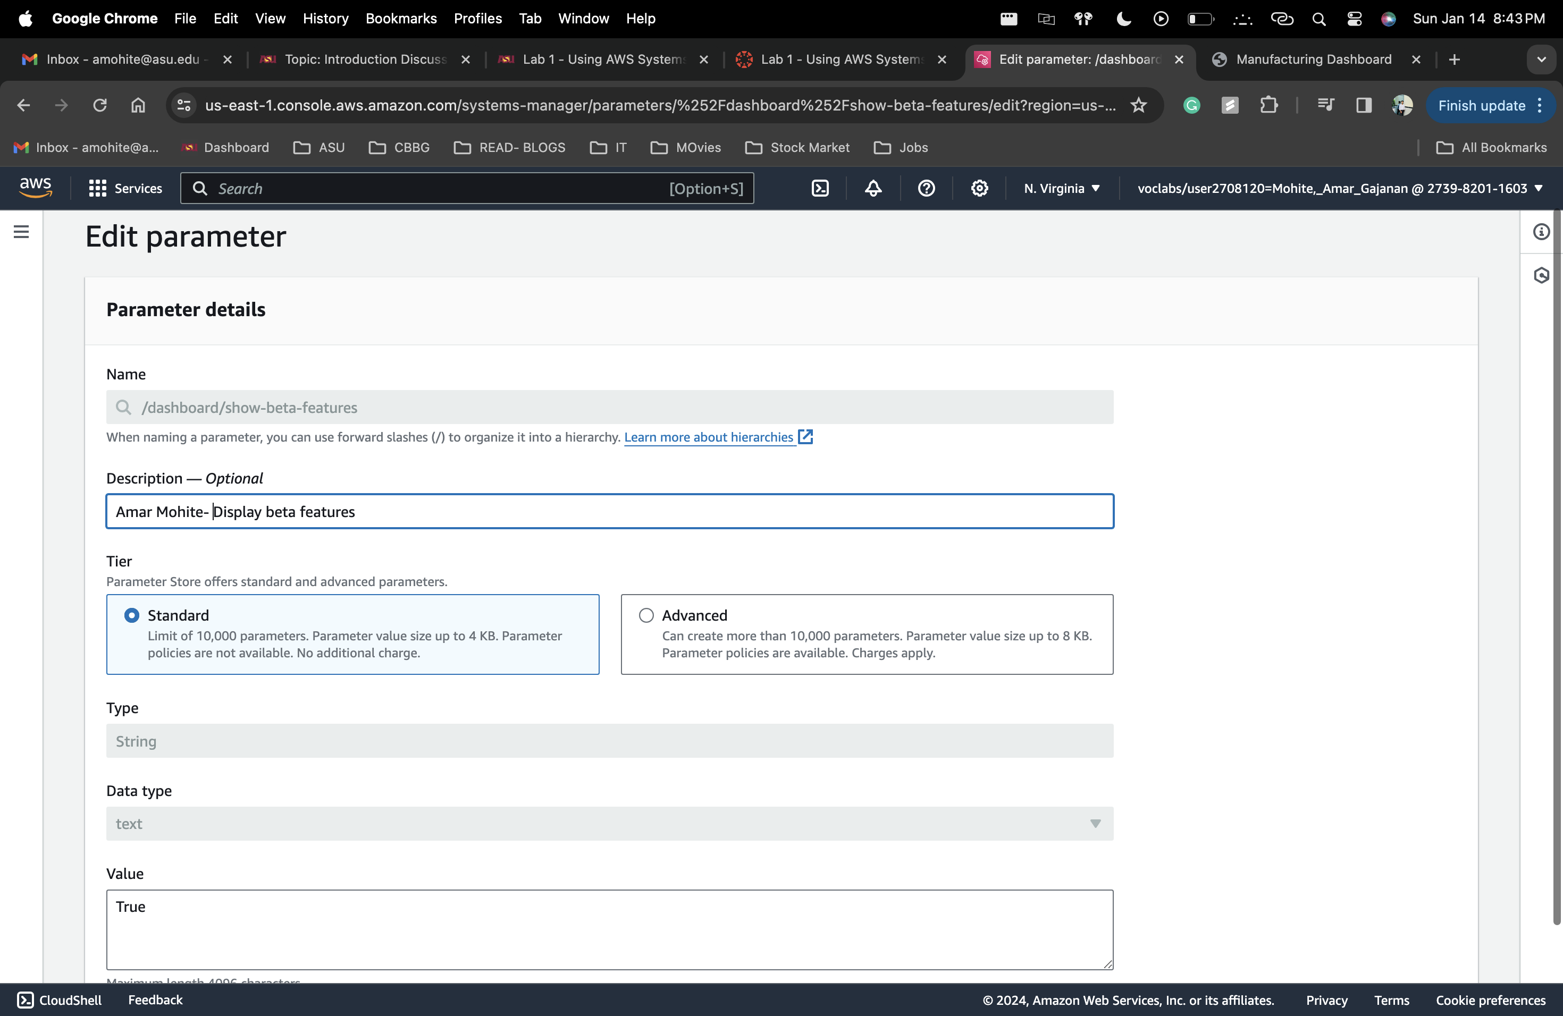

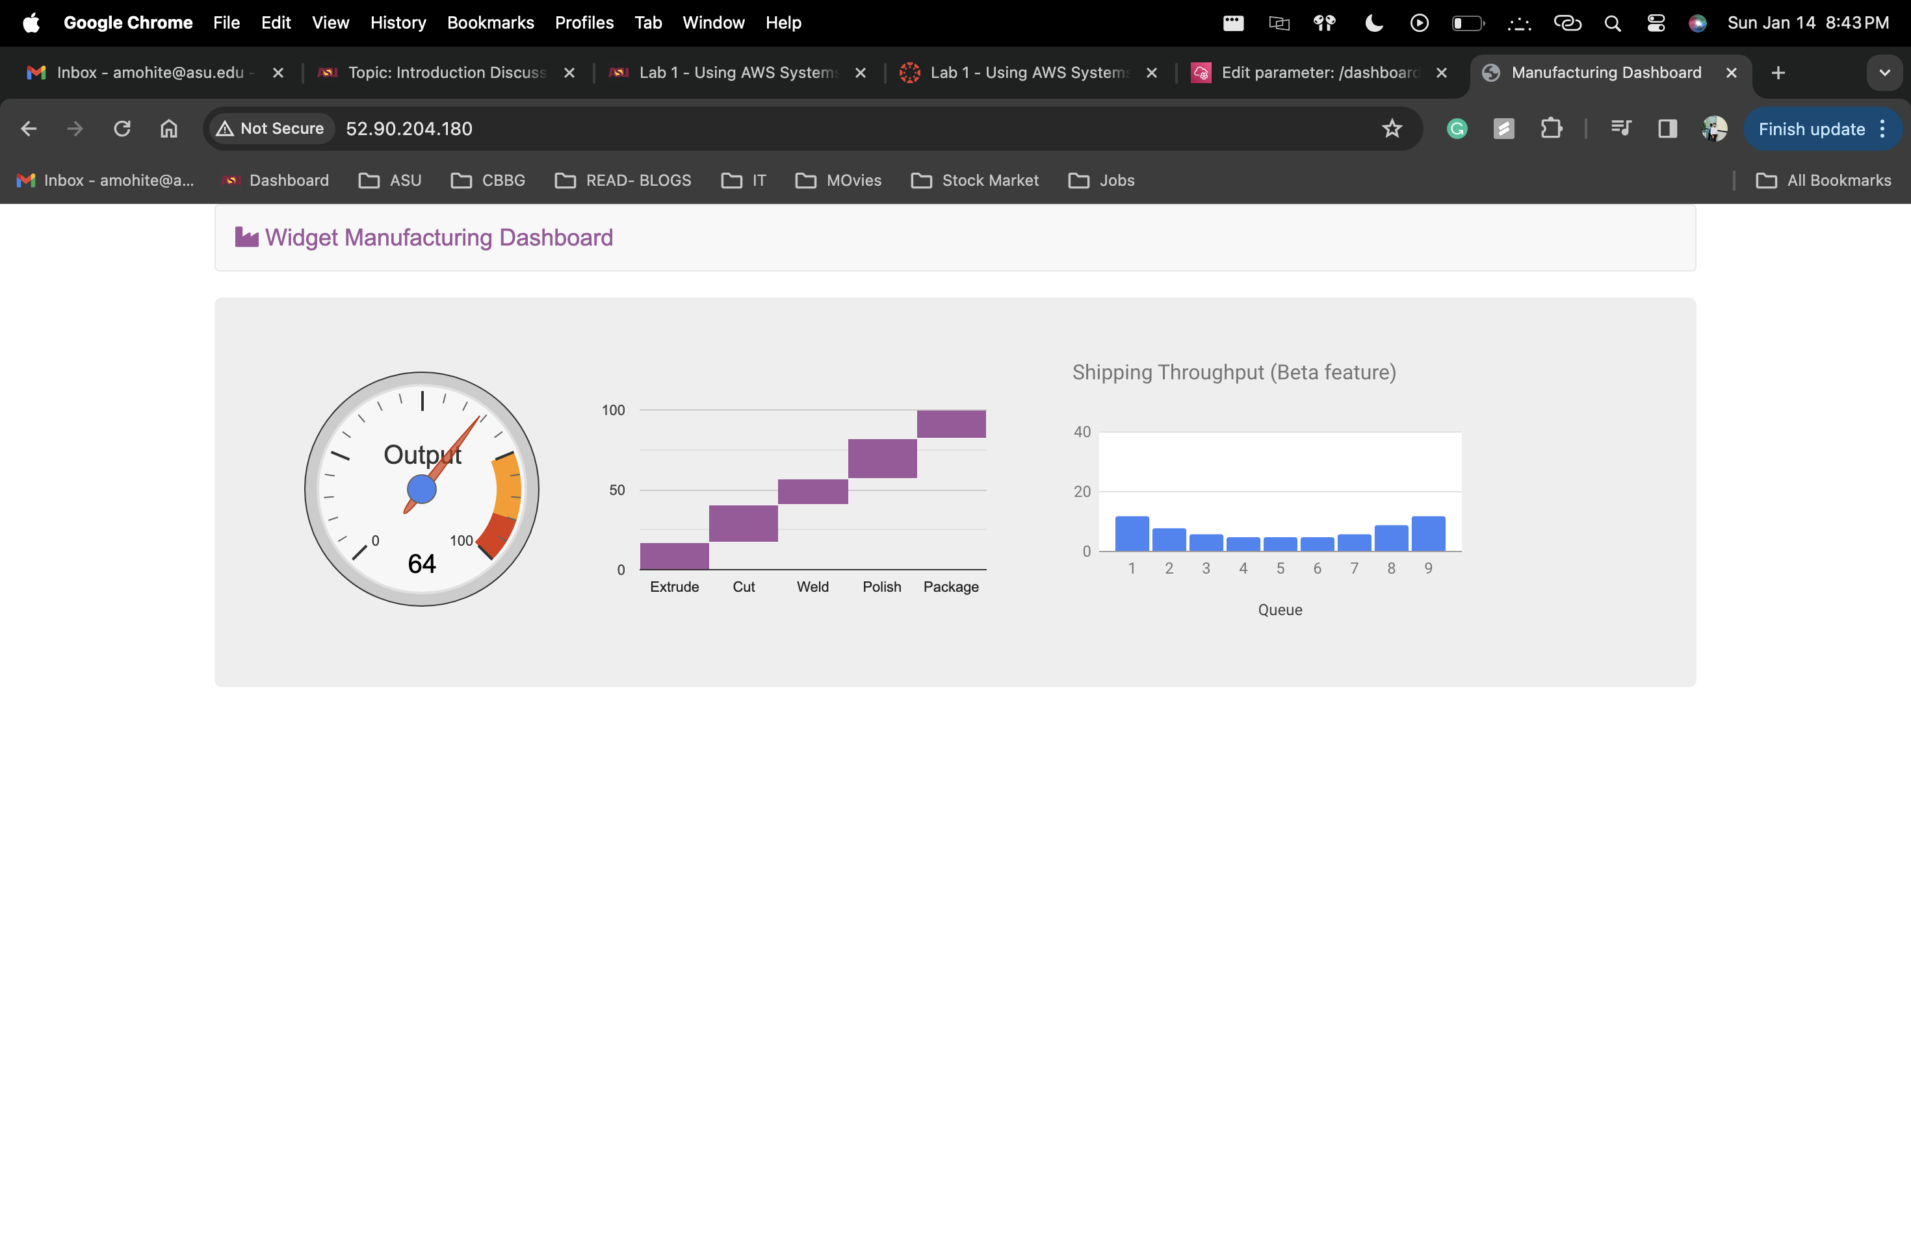

* The output of the console window from Task 4.  Add your full name to the command line.

